Guest Speaker”s”
August’s 1st Guest Speaker
David Lawler
David Lawler– Minerals Specialist/Geoscientist/Explorationist Mr. Lawler brings +30 years of experience in mineral exploration and development. His wide ranging and - diverse experience conducting assessments of precious metals, base metals, diamonds, gemstones and industrial minerals for numerous private investment
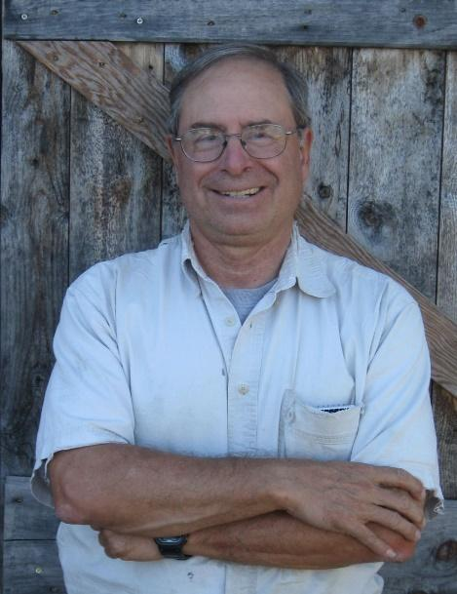
groups and mining companies on international and domestic mineral projects. He also has been instrumental in the evaluation, exploration and development of minerals deposits throughout North American and Latin America. He has been responsible for the discovery of several precious metal and gemstone deposits throughout his 30-year career. Mr. Lawler also serves as Executive Director of the Farwest Geoscience Foundation, a northern California educational and scientific 501(c3) non-profit foundation. The Foundation is devoted to geoscience educational outreach and scientific investigations in the Americas.
FWGF Talk: Comstock Reno Prospectors Club_(Reno, NV)_Sept27 2022_ Name: David Lawler – Minerals Specialist/Explorationist/Economic Geologist Company: Sierra Geosciences Group Address: PO Box 1681 Grass Valley, CA 95945 Email Address: lawassocgeosci@yahoo.com Abstract Title: Placer Gold Deposits of the Early Tertiary Age - Ancestral Yuba River System – Northern Sierra Nevada Region, California Talk Category: Mining, (Mineral Resource Development) ABSTRACT: Vast quantities of unmined gold-bearing (auriferous) gravels exist in the northern Sierra Nevada region of northern California. Specifically, these auriferous paleo-fluvial (river) deposits occur between the North Fork of the American River in Placer County and the South Fork of the Feather River in Plumas County. These gravel deposits have been accurately attributed to an immense paleo-river system termed the Ancestral Yuba River System. The paleo-river system existed between 55 million (Paleocene/Eocene) and 40 million years ago (Oligocene) during the early Tertiary geologic period. It extended over a large area of the present-day northern Sierra Nevada. A major portion of the total historic California placer gold production was derived from the ancestral Yuba deposits. The combined 19th & 20th century Ancestral Yuba production is approximately 20 million ounces ($35 Billion at current gold prices). The majority of the 20 million ounces was produced during the 1854- 1884 period, when hydraulic mining methods were developed and extensively using “industrial-scale” mine development methods. In 1884, a significant California State legal verdict was rendered, imposing a court injunction prohibiting the continued use of hydraulic mining methods at hydraulic placer gold mines located within the Sacramento River watershed and its tributaries. As a result of the 1884 court injunction, large volumes of unmined (virgin) auriferous gravels remain unworked in the northern Sierra Nevada region. Thus, an economically significant, placer gold resource still exists in this region. Several small-scale mine operations have successfully exploited portions of this paleo-gold placer over the last 50 years. The author will discuss past operational successes and current challenges against the backdrop of California’s “highly-regulated” environmental permitting setting.
Alert, our Guest David Lawler shall bring once again his maps for sale of:
Gold Deposits of the Early Tertiary Age - Ancestral Yuba River System – Northern Sierra Nevada Region, California Talk Category: Mining, (Mineral Resource Development) ABSTRACT: Vast quantities of unmined gold-bearing (auriferous) gravels exist in the northern Sierra Nevada region of northern California.

August’s 2nd Guest Speaker
Rick Solinski
___________________________________________________________________________

On our Club’s Board, Membership Chairman Jeff Benik’s had conversations with Mr. Solinski. He was intrigued and asked him to speak at this month’s meeting. He accepted…“Fantastic” I said and so we’re proceeding with enjoying two speakers this Tuesday! We’re really glad to hear from Rick can be another Guest Speaker. Meeting shall start early to cover Club business and to enjoy new ideas by our guests!

